**Assignment – 2**

**Student Name:** Vivek Kumar  **UID:** 21BCS8129

**Branch:** BE-CSE (LEET) **Section/Group:** 809/A

**Semester:** 4th **Date of Performance:** 02/04/2022

**Subject Name:** Computer Network **Subject Code:** 20CSP-256

**1. Aim/Overview of the practical:**

Elaborate sliding window flow control mechanism with example. Also differentiate it with stop and wait method.

**Theories:**

Sliding window protocols are data link layer protocols for reliable and sequential delivery of data frames. The sliding window is also used in Transmission Control Protocol.

In these protocols, the sender has a buffer called the sending window and the receiver has buffer called the receiving window. The size of the sending window determines the sequence number of the outbound frames. If the sequence number of the frames is an n-bit field, then the range of sequence numbers that can be assigned is 0 to 2𝑛−1. Consequently, the size of the sending window is 2𝑛−1. Thus, in order to accommodate a sending window size of 2𝑛−1, a n-bit sequence number is chosen.

Suppose that we have sender window and receiver window each of size 4. So, the sequence numbering of both the windows will be 0,1,2,3,0,1,2 and so on. The following diagram shows the positions of the windows after sending the frames and receiving acknowledgments.

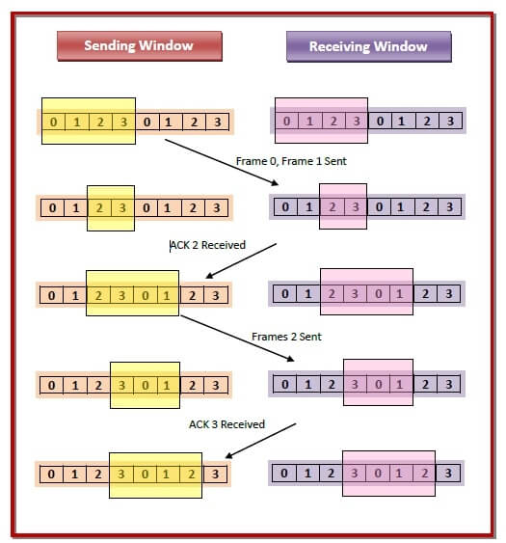

**Evaluation Grid (To be created as per the SOP and Assessment guidelines by the faculty):**

|  |  |  |  |
| --- | --- | --- | --- |
| Sr. No. | Parameters | Marks Obtained | Maximum Marks |
| 1. |  |  |  |
| 2. |  |  |  |
| 3. |  |  |  |
|  |  |  |  |